10. How to create a Night check timeline report

- Click on the Administration ‘cog’ in the vertical menu on the left hand side –

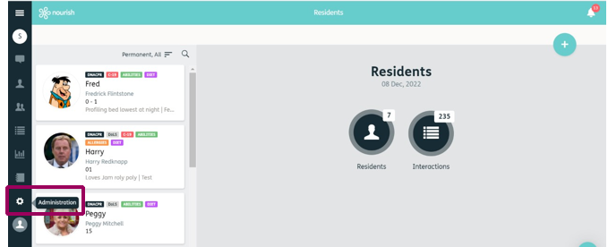
1.

- This will open the Administration Menu, click on ‘Reports’ –
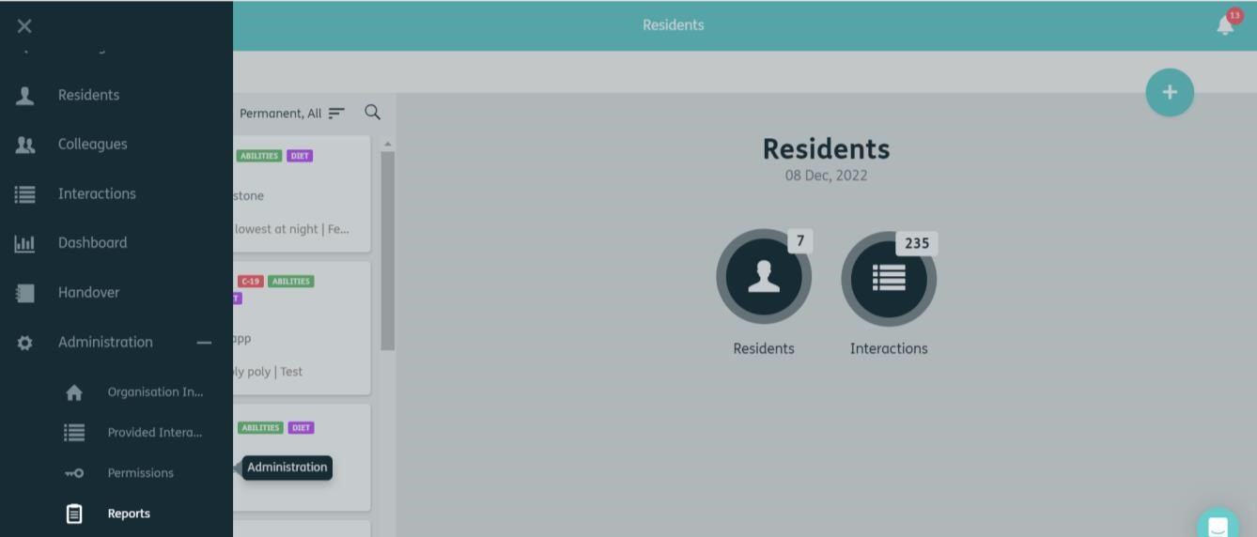

2.

- This will open the reports menu. To create a new report, click on the ‘Blue Plus’ in the top right corner.

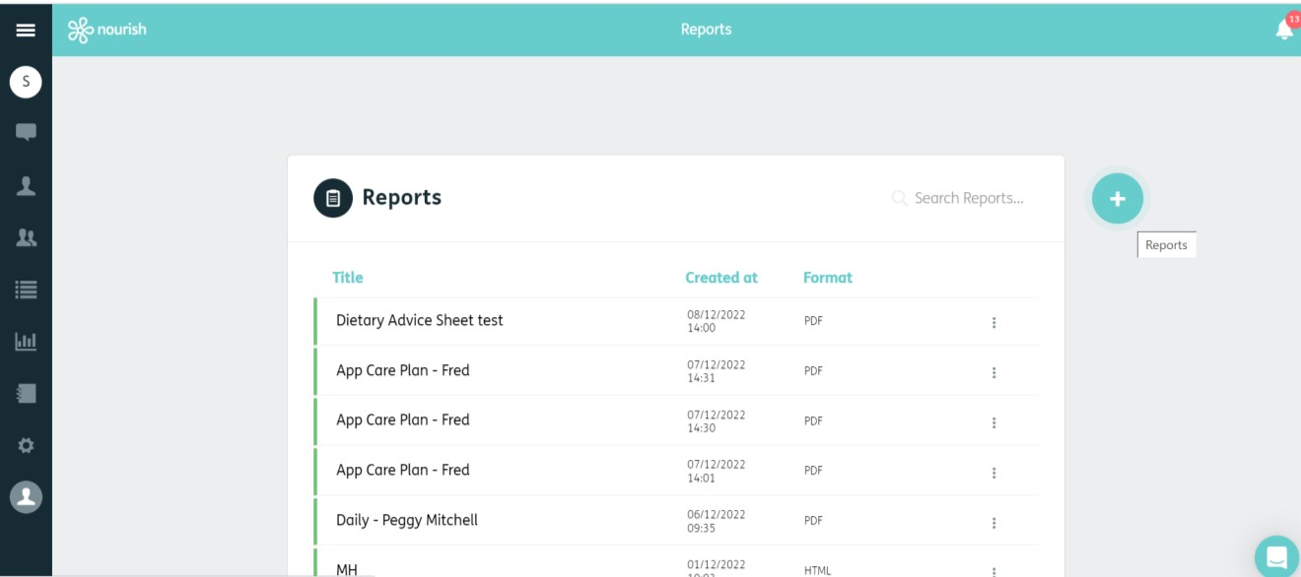

3.

- You can now create a new report, choose ‘Timeline’ from the drop down box.

- Give your report a title (remember reports stay in the report list)

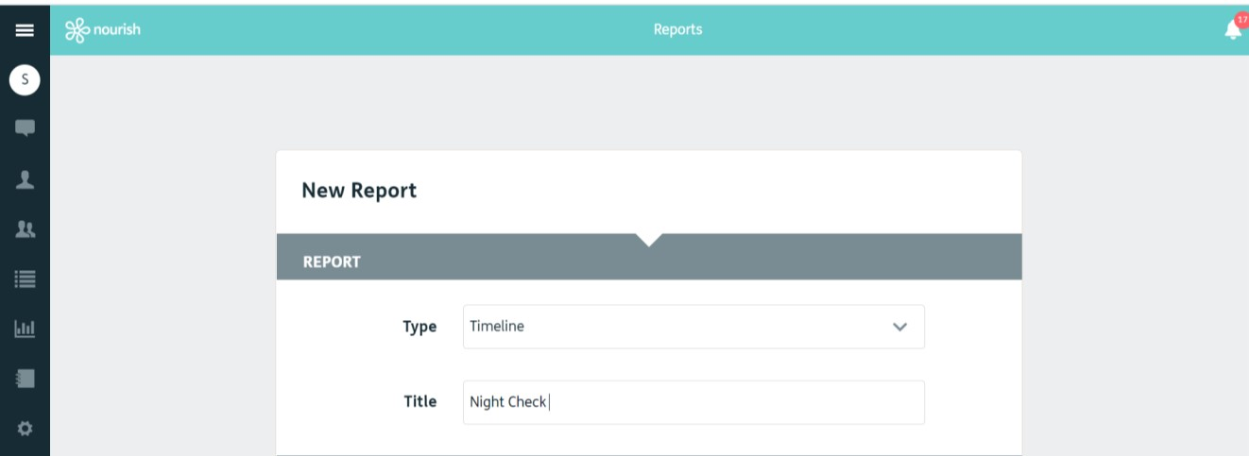
4.

5.

- Choose your date range -

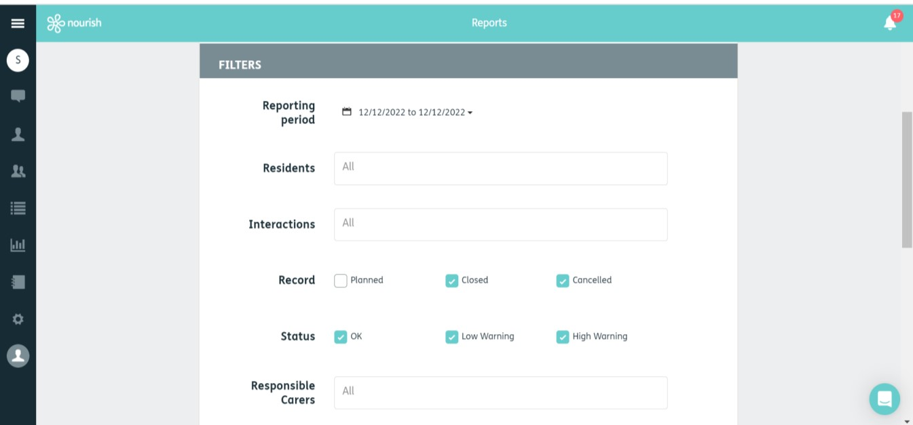

6.

- Choose the resident / residents or leave at ‘All’ (if you start typing a name in the box, it will auto-populate) –



7.

- Select the interactions (it will auto-populate if you start typing in the box). For this report you will need to select ‘Night Check’ –

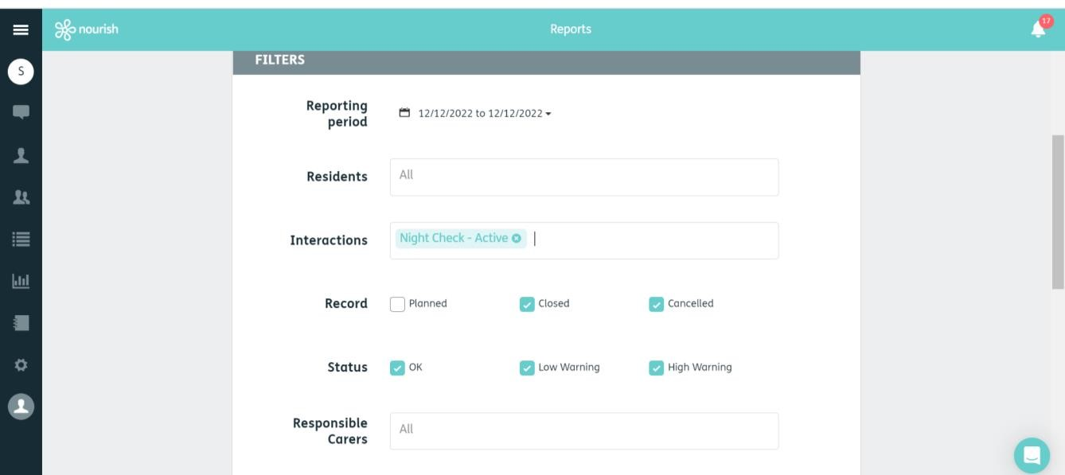

8.

- Leave the boxes ticked as they are shown below.

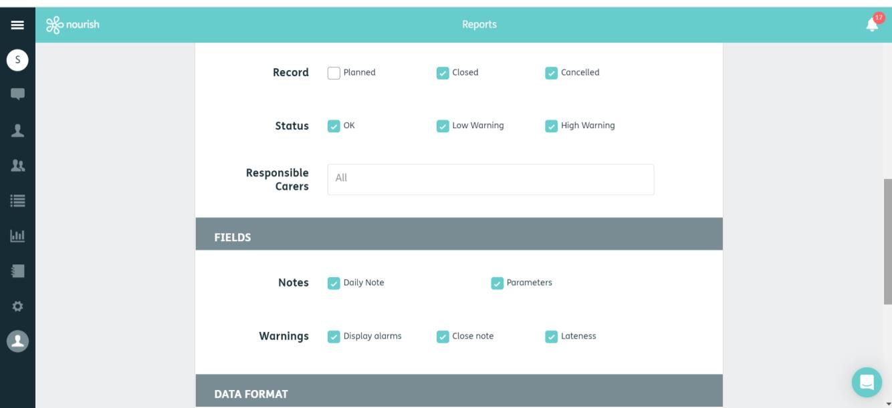

9.

9.

- You can then select your format (recommended PDF)
- Click Save

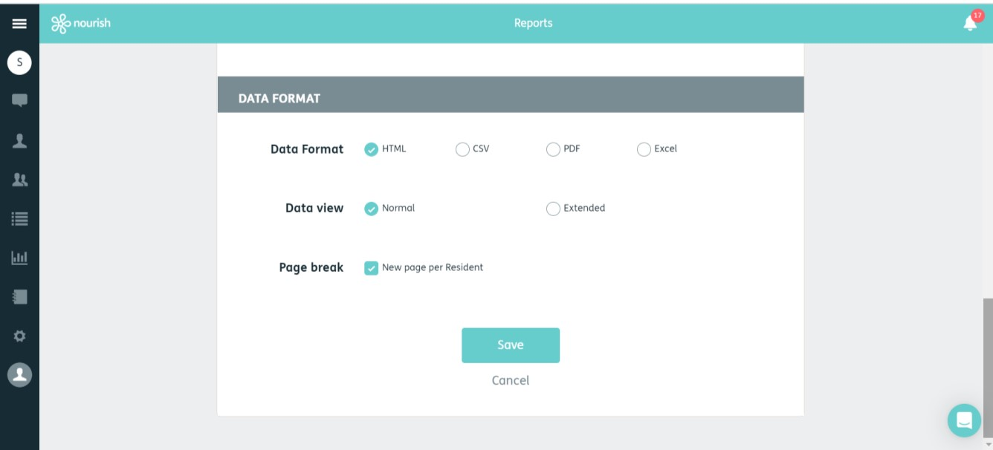

11.

- You can now download your report.

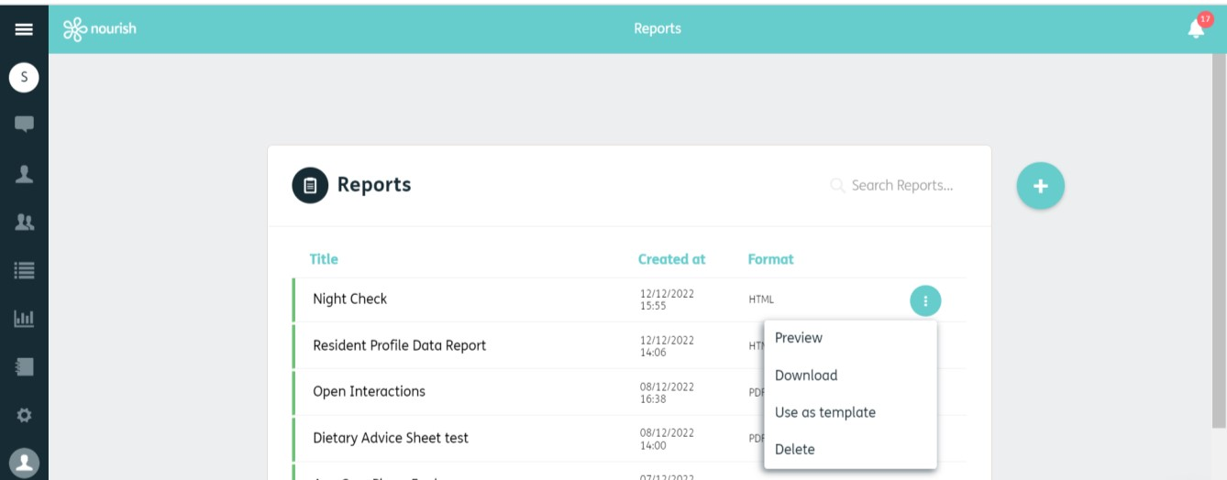

12.

